**FREE VIBRATION OF CANTILEVER BEAM Procedure**

There are Three modes of simulation provided (i) EXPLAIN (expN) (ii) EXPLORE (expR) and (iii) EXPERIEMNT (expT)

**EXPLAIN (expN):** The simulation is explained with narration, how to use the simulation, it is a self-running demo or a talking tutorial.

**EXPLORE (expR):** Where in the user is allowed to vary all the parameter and try out how the result is varying and explore all the possible combinations.

**EXPERIMENT (expT):** A selected few parameters are user modifiable and few parameters are set by the system. Then the user is asked run the experiment and based on the observation, find out the numerical value of the given parameter and submit the results. The system checks the correctness of the value entered.

**Aim of the experiment**: Determine the natural frequency of a given beam, repeat the experiment for various cross sections and material combination along with different length of the beam.

**Procedure to conduct the experiment:**

The following parameters can be changed in the simulation platform:

* Cross section of the cantilever beam.

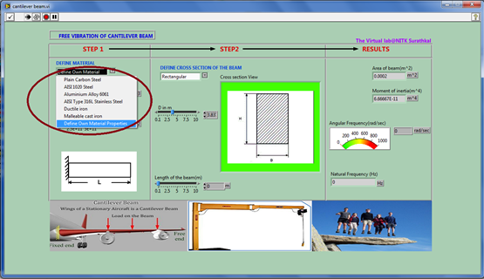

* Material of the cantilever beam.

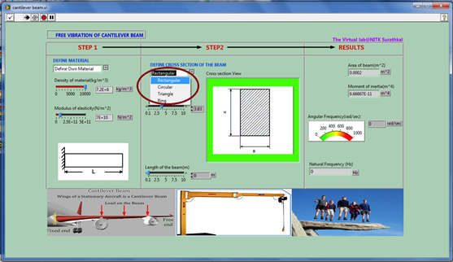

User can choose own material and provide required material property

* Effective length of cantilever beam.

The results that we arrive at are:

* Natural frequency of the system.

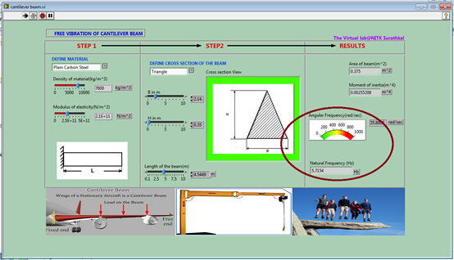

In the EXPLORE (expR) mode of simulation for any given combination of material, cross section and beam length, system calculate the natural frequency and give to the user.

In the EXPERIMENT (expT) mode, user can choose material, cross section and length of the beam, the system calculates mass and area moment and display, user is expected to calculate the natural frequency and enter the calculated value and submits the answer. The correctness of the answer will be informed to the user.

**Observation**

|  |  |  |  |  |  |
| --- | --- | --- | --- | --- | --- |
| SlNo | Cross section | Section Property (b,h, or diameter ) | Length | Young’s modulus (E) | Density (ρ) |
|  |  |  |  |  |  |
|  |  |  |  |  |  |
|  |  |  |  |  |  |
|  |  |  |  |  |  |

**Calculations**

|  |  |  |  |  |  |
| --- | --- | --- | --- | --- | --- |
| SlNo | Area (A) | Area moment (I) | Mass (M ) | Stiffness (K) | Natural Frequency (ωn) |
|  |  |  |  |  |  |
|  |  |  |  |  |  |
|  |  |  |  |  |  |
|  |  |  |  |  |  |

**Inference and Conclusions**

{find out how the natural frequency varies with each of the variables , and write in your own word the collusion from the experiment}

Further reading beyond this experiment:

**Effective mass of a continuous system**

In an experimental set up however, the cantilever beam acts as a continuous mass system. Hence an effective mass for the system needs to be calculated.

By referring to <http://teaching.ust.hk>, we have arrived at the following soln. For the effective mass.

$$m_{effective }=0.0235ρl+m$$

where

m= end mass (sensing element etc.) (kg)

$ρ$ = mass density of material of cantilever system (mass/unlit length)(kg/m)

$l$ = length of the cantilever beam (m)

**Energy consuming element – Damping**

If we introduce energy consuming element called damping then the equation get modified to

$M\ddot{x}+C\dot{x}+Kx= 0$; $\ddot{x}+2ζω_{n}\dot{x}+ω_{n}^{2}x=0$

Where

x = displacement of the free end of the cantilever beam (m)

C = Damping present in the system (Kg/s)

$ζ$ = Damping Coefficient of the system

**The solution for SDOF damped free vibration governing equation**

The solution to the above system changes depending on the initial conditions $x_{o}$ = initial displacement and $v_{o}$ = initial velocity, the damping coefficient = $ζ$

Let us consider the 3 cases:

CASE 1: $ζ$ = damping coefficient < 1 (Underdamped systems.)

$$x\left(t\right)=e^{-ζω_{n}t}[\left(x_{o}\cos{{(ω}_{d}t)}\right)+$$

$$\frac{\left(v_{o}t+ ζ ω_{n}x_{o}\right)}{ω_{d}}sin{(ω}_{d}t)]$$

Where ${\text{ω}}_{\text{d }}$ = damped natural frequency = $\sqrt{(1-ζ^{2} )} ×ω_{n}$

CASE 2: $ζ$ = damping coefficient = 1 (Critically damped systems.)

$$x\left(t\right)=e^{-ω_{n}t}\left[\left(x_{o}\right)+\left({(v}_{o}+ ω_{n}x_{o}\right)t\right]$$

CASE 3: $ζ$ = damping coefficient > 1 (Overdamped systems.)

$x\left(t\right)=e^{-ζ+{\left(\sqrt{ζ^{2}}-1\right)ω}_{n}t} \left[\frac{\left(x_{o}(ζ+{\left(\sqrt{ζ^{2}}-1\right)ω}_{n}\right)+v_{o}}{2{\left(\sqrt{ζ^{2}}-1\right)ω}_{n}}\right] +e^{-ζ-{\left(\sqrt{ζ^{2}}-1\right)ω}_{n}t} \left[\frac{\left(– x_{o}(ζ-{\left(\sqrt{ζ^{2}}-1\right)ω}_{n}\right)-v_{o}}{2{\left(\sqrt{ζ^{2}}-1\right)ω}_{n}}\right]$